**Name –** Bodke Sairaj Nivrutti.

**Class –** BE Artificial Intelligence and Data Science.

# Roll No. – 09

**Practical No. 05 -** Write a program for performing industrial data analysis using relevant tools and techniques.

# Circuit Diagram –

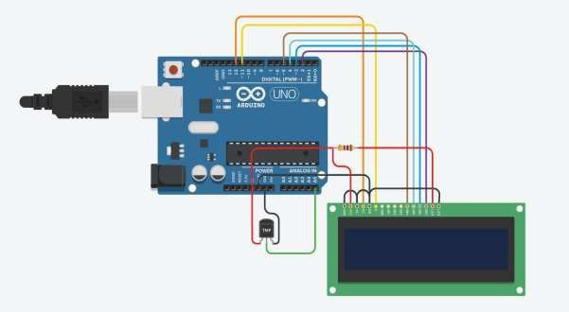

**Source Code –**

#include <LiquidCrystal.h> // Include the LCD library

// Initialize the LCD with the number of columns and rows LiquidCrystal lcd(12, 11, 5, 4, 3, 2);

const int tempPin = A0; // Analog pin connected to the LM35

void setup() {

lcd.begin(16, 2); // Set up the LCD's number of columns and rows lcd.print("Temp: "); // Print a message to the LCD

}

void loop() {

int analogValue = analogRead(tempPin); // Read the analog value from LM35 float voltage = analogValue * (5.0 / 1023.0); // Convert the analog value to voltage float temperatureC = voltage * 100; // Convert voltage to temperature in Celsius

lcd.setCursor(0, 1); // Set cursor to the beginning of the second line lcd.print("Temp: ");

lcd.print(temperatureC); // Print the temperature to the LCD lcd.print(" C");

delay(1000); // Wait for a second before updating the display

}

# Output –

